

Summary of Funding Trends for Campaigns

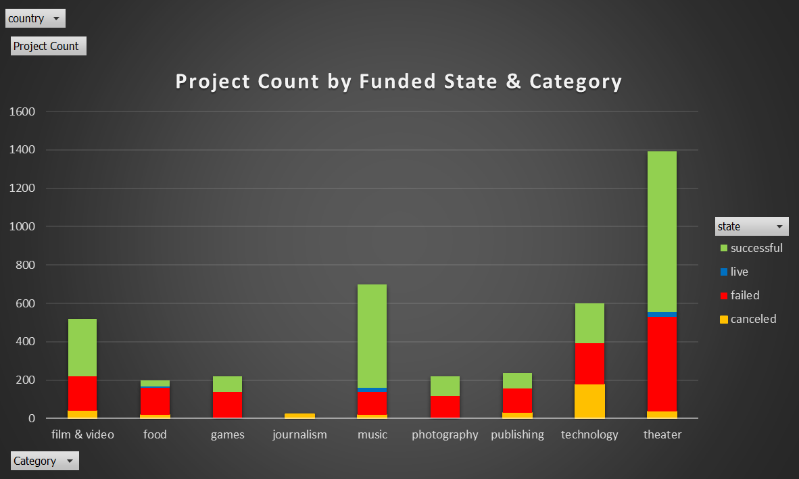**Conclusions from Funding Data**

* Based on total number of projects, Theater appears to be a popular project type on Kickstarter. Journalism is not a popular category.

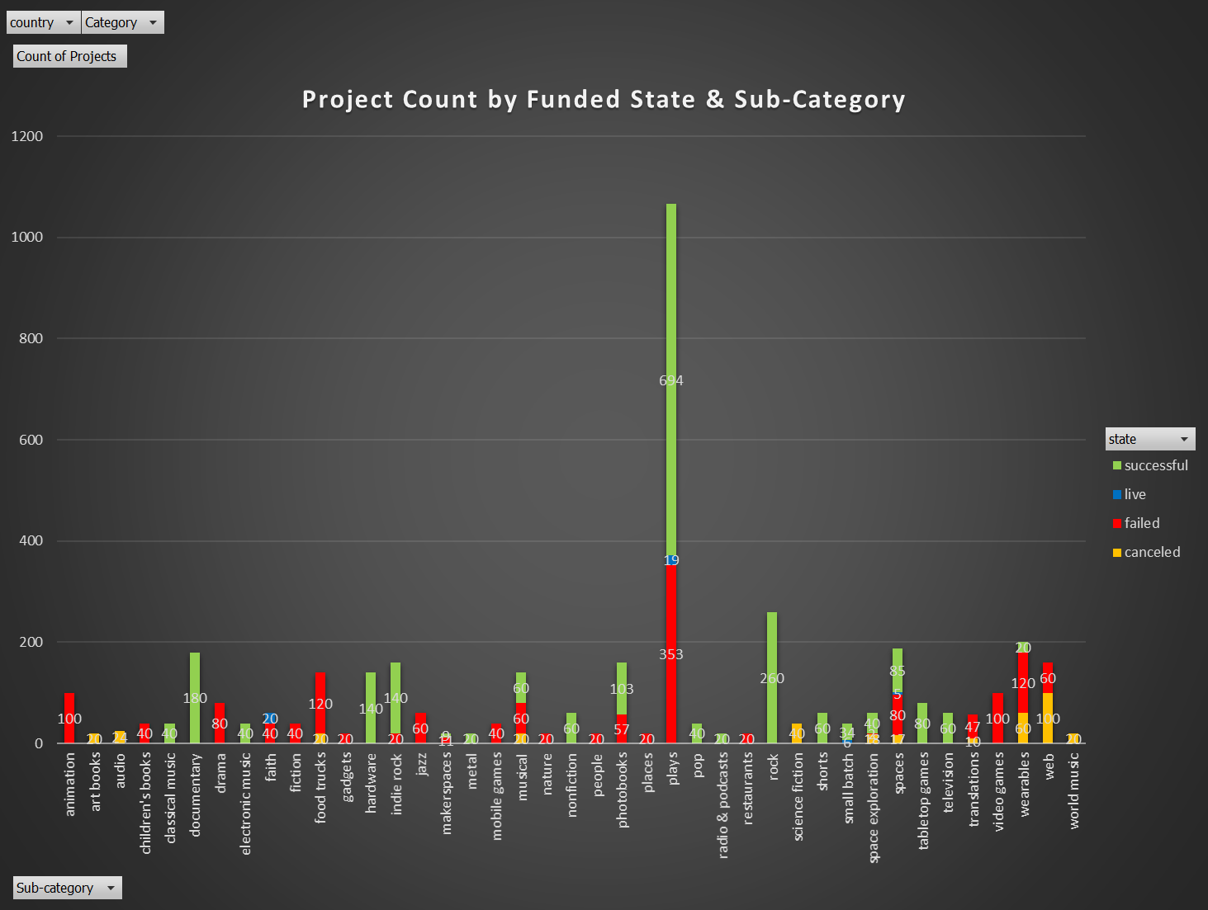

* Projects in the Rock sub-category were 100% successful in funding, suggesting this may be a good category to choose for funding success.
* 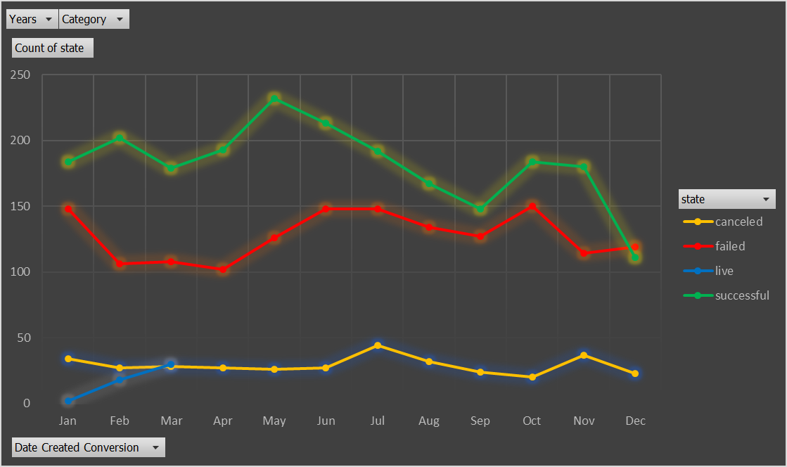The month of May be the best month to launch a project, as the most successful projects have launched in that month.

**Dataset Limitations**

* There may be other project factors not included in this dataset that might provide additional insights on the funded states
* The backers on Kickstarter may represent a population that is more likely to support the types of projects that were successfully funded, or less likely to support those that were canceled or failed

Ideas for Additional Analysis

* Build a graph that compares the funded state of the projects to the duration of the campaign to see if there is relationship in length of campaign to success or failure.
* Create a chart that shows the number of backers by the funded state of the projects to see if number of backers relates to project success
  + Support this with a regression analysis to compare the variables